Hong Kong-Macao Digital Skills Competition 2026

Test Project
Module B Functionality
Mobile Applications Development

Contents

Introduction 3
Description of project and tasks 3
1. General Demands 5
2. Page Demands 6
2.1 Lottery Page UI Elements 6
2.2 Lottery Page Functional Requirements 7
3. Competitors Page Demands 8
3.1 Competitors Page UI Elements 8
3.2 Competitors Page Functional Requirements 8
4. Add/Edit Page Demands 9
4.1 Add/Edit Page UI Elements 9
4.2 Add/Edit Page Functional Requirements 9

Introduction
WorldSkills chief experts often need to organise fair seat allocation before a competition begins. The Seat Lottery app helps the chief expert randomly select competitors by trade, assign them to seats by shaking the phone, and preserve important locked seat assignments.
As a Mobile Application Developer, your task is to develop a phone application based on the supplied wireframes and data files. The application must support a trade-based lottery workflow, competitor list management, reset with locked seats, and persistent storage.
(The best app maybe selected to be the actual lottery app used in WSC Shanghai 2026 :) )

Description of project and tasks
You do not need to copy the wireframe pixel by pixel, but the required elements, interactions, and data behaviour must be implemented clearly and be easy to use.
 | PART | NAME | COMPETITION TIME | MARKING DEVICES
✓ | -- | Functionality (phone) | 2.5 hours | Android Emulator or,  iOS Simulator

Below is an overview of the wireframes. Please check the media files for details.
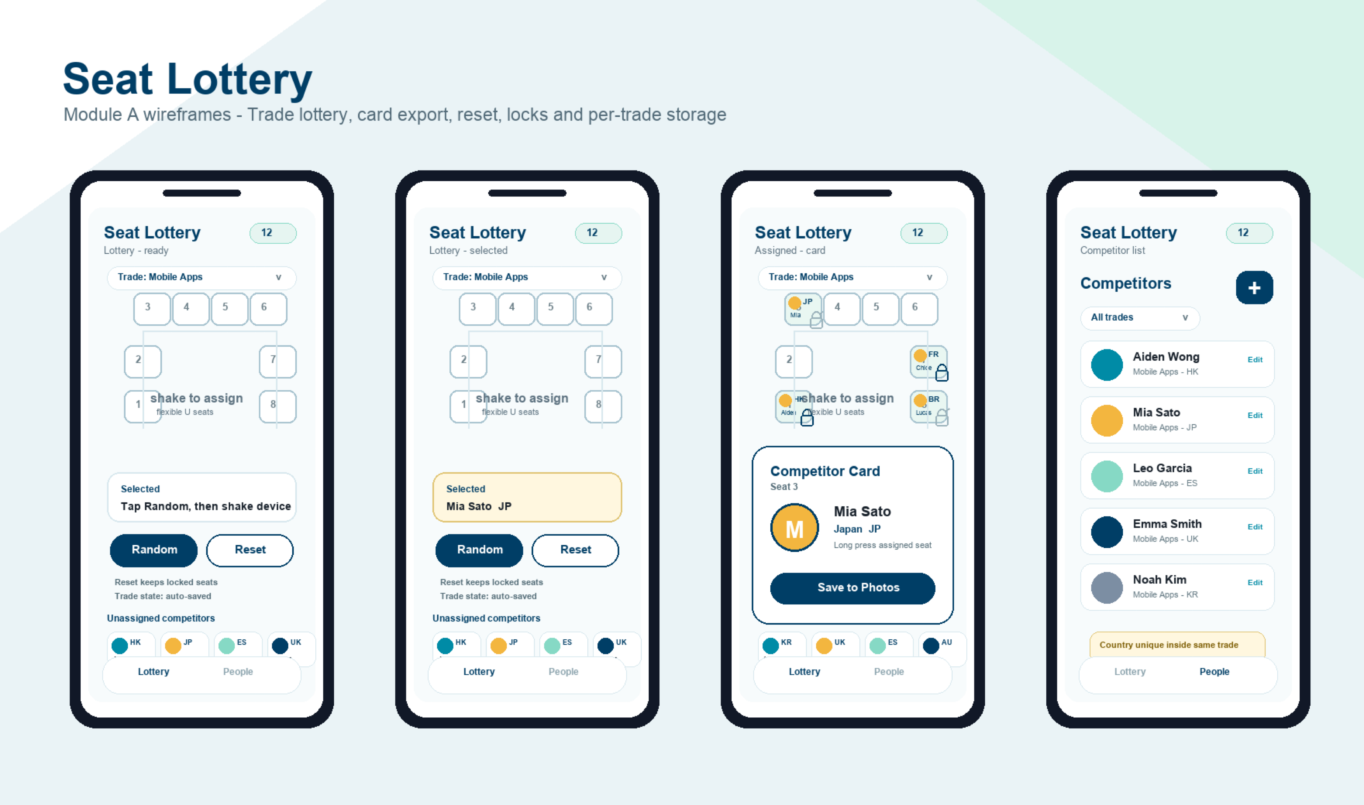
The Lottery Page (Tap to get Competitor/Shake to Assignment/Competitor Card) and Competitor Page

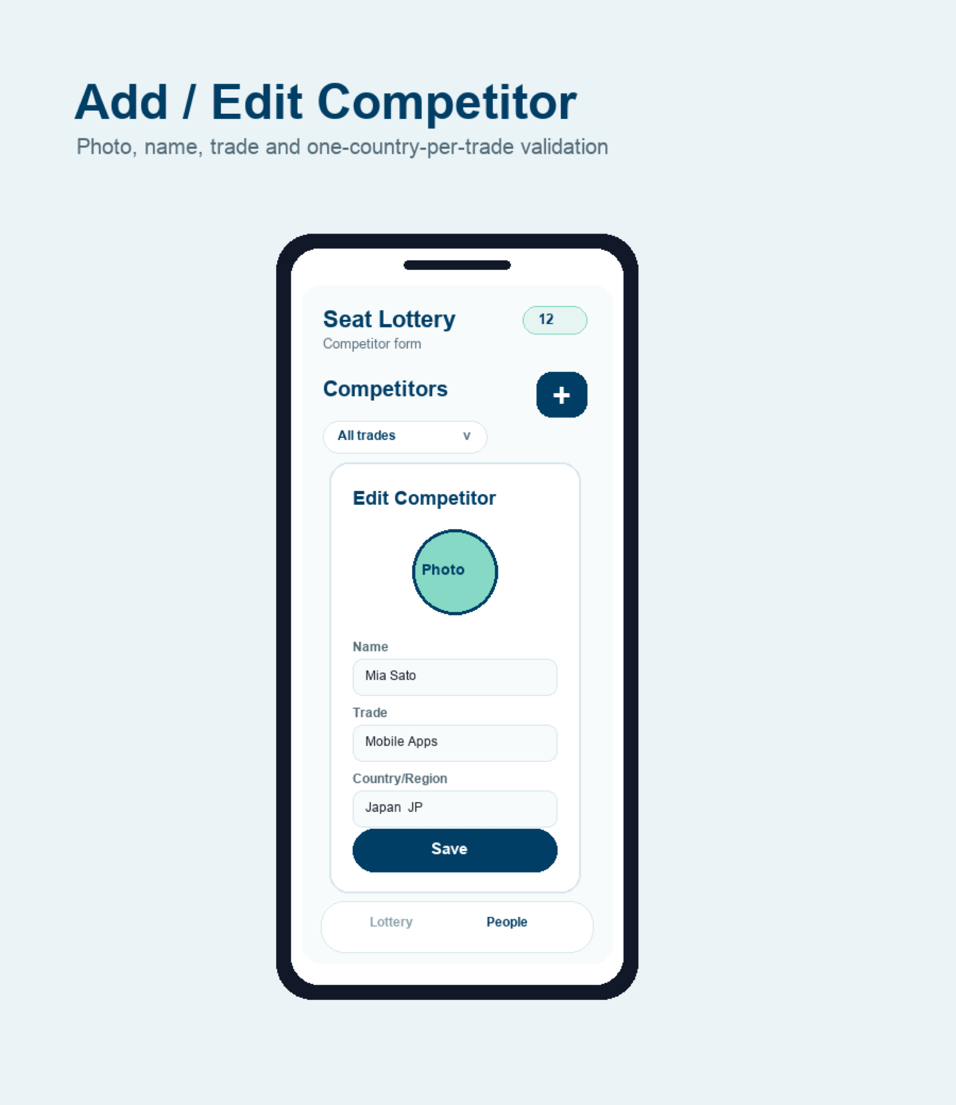

The Add/Edit competitor Page

1. General Demands
1.1 Finish the function of this application according to the demands.
1.2 The application should remain in portrait orientation.
1.3 The application needs to display the application name "Seat Lottery" in the operating system.
1.4 The application needs to display an application icon in the operating system.
1.5 The bundle identifier must be set to "com.worldskills.app".
1.6 The application must contain two tabs with icons: Lottery and Competitors.
1.7 The application must provide the trades Software Testing and Mobile Applications Development.
1.8 Competitor data, selected trade, per-trade seat assignments, locked seat states, and remaining unassigned competitors must be stored persistently.

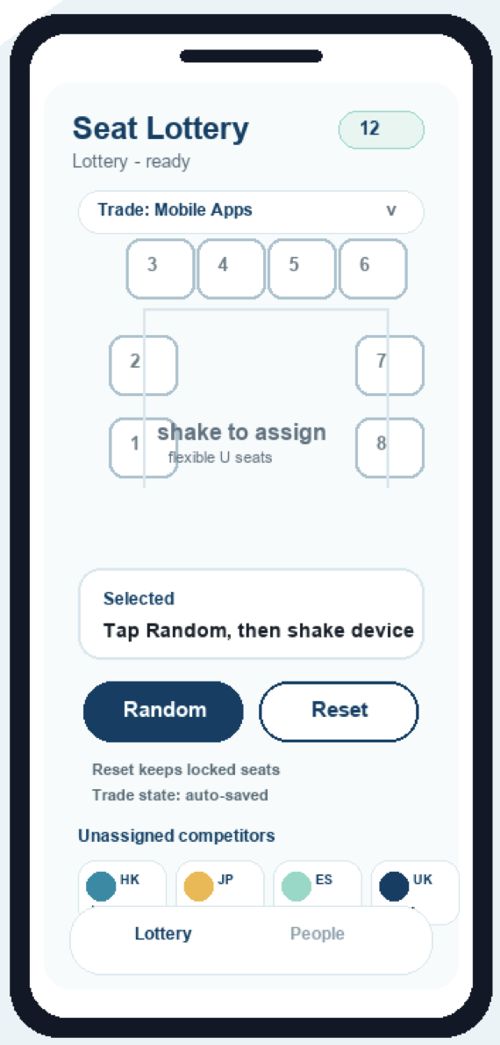

2. Page Demands

2.1 Lottery Page UI Elements
General UI:
2.1.1 A flexible U-shaped seating area for 6 or more competitors.
2.1.2 The top row contains 3 seats for odd layouts or 4 seats for even layouts, depending on the number of competitors.
2.1.3 Remaining seats are distributed down the left and right sides of the U shape.
2.1.4 A clear empty centre area showing the text "shake to assign".
2.1.5 A trade selector showing the current WorldSkills trade.
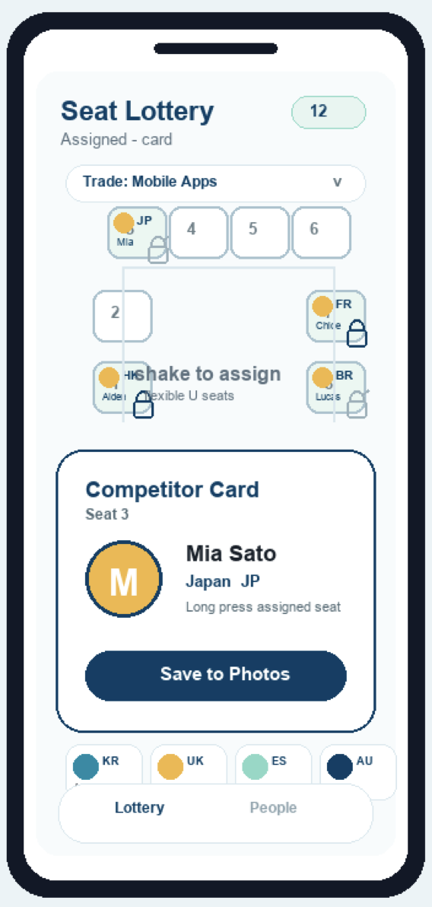
2.1.6 A selected competitor area.
2.1.7 A "Random" button.
2.1.8 A "Reset" button.
2.1.9 A locked/unlocked indicator for assigned seats.
Competitor Card:
2.1.10 A competitor card pop-up for an assigned seat.
2.1.11 A "Save to Photos" action on the competitor card.
2.1.12 A bottom list of unassigned competitors for the selected trade. Each item shows competitor name, thumbnail, and flag emoji/country indicator.
2.1.13 Assigned seats displaying competitor name, thumbnail, and flag emoji/country indicator.

2.2 Lottery Page Functional Requirements
2.2.1 When the Lottery tab is opened, the user can select a trade from Software Testing or Mobile Applications Development.
2.2.2 The bottom list displays only unassigned competitors from the selected trade.
2.2.3 Tap the "Random" button to randomly select one competitor from the selected trade who has not been assigned.
2.2.4 After a competitor is selected, shaking the phone assigns that competitor to a valid empty seat for the selected trade.
2.2.5 After assignment, the seat displays the competitor's name, thumbnail, and flag emoji/country indicator.
2.2.6 After assignment, that competitor is removed from the selected trade's bottom list.
2.2.7 The same competitor cannot be assigned to more than one seat in the same trade.
2.2.8 The user can lock or unlock an assigned seat.
2.2.9 Long press an assigned seat to display a competitor card for that seat.
2.2.10 The competitor card must show the competitor's photo/thumbnail, name, country/region, flag emoji/country indicator, and seat number.
2.2.11 The competitor card can be saved as an image to the system photo gallery.
2.2.12 Tap the "Reset" button to clear all unlocked seat assignments for the selected trade.
2.2.13 When Reset is tapped, locked seats remain assigned and locked competitors must not return to the selected trade's bottom list.
2.2.14 After Reset, competitors from unlocked seats return to the selected trade's bottom list and can be selected again.
2.2.15 When the user switches trade, the app must load that trade's previous lottery state.
2.2.16 Per-trade seat assignments, locked states, selected competitor, and unassigned competitor list must be restored when the app is reopened.
2.2.17 If there is no selected competitor, shaking the device must not assign any seat.
2.2.18 If all competitors have been assigned, the app should show a completed state and disable random selection.

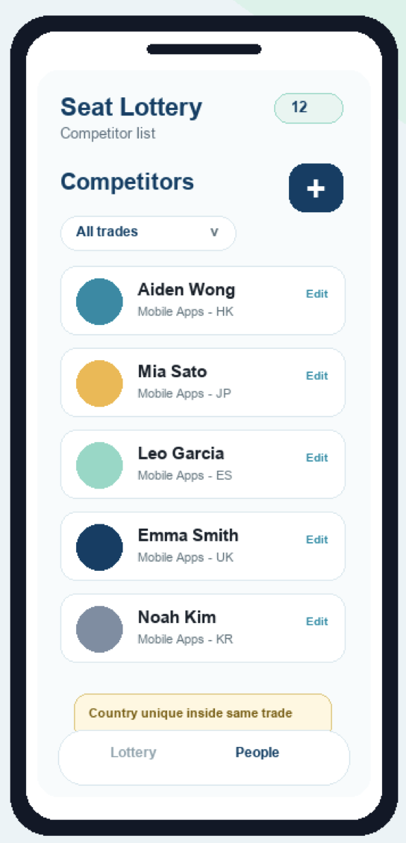
3. Competitors Page Demands

3.1 Competitors Page UI Elements
3.1.1 A list of competitors.
3.1.2 An add button.
3.1.3 A trade filter or trade indicator for the competitor list.
3.1.4 Each list item shows photo/thumbnail, name, trade, and country/region.
3.1.5 An edit action for each competitor.

3.2 Competitors Page Functional Requirements
3.2.1 When the Competitors tab is opened, the app displays all saved competitors.
3.2.2 The user can filter or identify competitors by trade.
3.2.3 Tap the add button to open the Add/Edit page for a new competitor.
3.2.4 Tap an existing competitor's edit action to open the Add/Edit page with existing data loaded.
3.2.5 Changes to the competitor list must persist after closing and reopening the app.

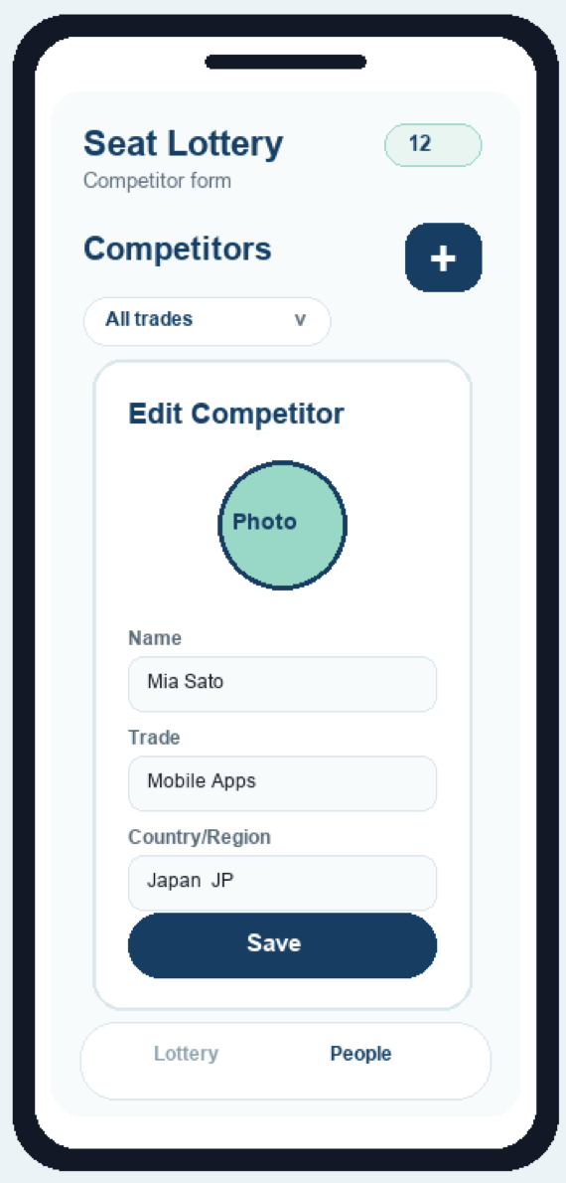

4. Add/Edit Page Demands

4.1 Add/Edit Page UI Elements
4.1.1 A photo/thumbnail picker.
4.1.2 A competitor name input.
4.1.3 A trade picker using trades.json.
4.1.4 A country/region picker using countries.json.
4.1.5 A Save button.
4.1.6 A validation message area for duplicate or missing information.

4.2 Add/Edit Page Functional Requirements
4.2.1 The user can choose or capture a photo/thumbnail for the competitor.
4.2.2 The user can enter the competitor name.
4.2.3 The user can select one trade from trades.json.
4.2.4 The user can select one country/region from countries.json.
4.2.5 Each country/region can be used by only one competitor within the same trade.
4.2.6 If the selected country/region is already used in the same trade, the app must prevent saving and show a clear validation message.
4.2.7 Saving a new competitor adds the competitor to the Competitors page.
4.2.8 Saving an existing competitor updates the competitor, including their trade.
4.2.9 Saved add/edit changes must persist after closing and reopening the app.

5. Data Files
File | Purpose
trades.json | Trade picker seed containing Software Testing and Mobile Applications Development.
countries.json | Country/region picker seed with code, name, and flag emoji.
default.json | Default trade and competitor list loaded when no saved data exists.
test_data_1.json | Small single-trade test set for 6 competitors.
test_data_2.json | Medium two-trade test set for 12 competitors.
test_data_3.json | Larger two-trade test set for 16 competitors.

6. Instructions to the Competitor
6.1 Please create the project with the correct package name (Android) / bundle identifier (iOS): com.worldskills.app.
6.2 You should save the project in the folder XX_Module_B.
6.3 You should rename the generated apk (Android) / app (iOS) file as XX_Module_B.apk (Android) / XX_Module_B.app (iOS) and save it in the root of the XX_Module_B folder.
6.4 The whole XX_Module_B folder should be pushed to the provided remote Git repository in time.
6.5 Note: "XX" is your country/region code.

